**GROUP PROJECT, GROUP 3**

**DATE: 23 October 2018**

**TIME: 13:00PM – 18:45PM**

**ATTENDEES** Tom Gibbs, Henry Crofts

**LOCATION:** A2.07, Atrium Building

**Minute Taker: Henry Crofts**

**Overall aims of the current sprint *(Detailed tasks, user stories and time allocations are tracked on JIRA)***

* To apply design theory principles to the Management Game.
* Spend time in labs together to improve team efficiency.
* Book meetings with Rob Kurta, Dave Pimm, and Chris Janes.

**Meeting:**

All team present.

The team met up and started to discuss what will be required / recommended for the next presentation with the stakeholders (tutors) so as a team we started to go over;

* Psychographic
* Demographic
* Why will the player stay
  + Revisited the *“Hooked”* model to ensure we have all elements to keep the player hooked.
  + Revisited the *“4KeysToFun”* model to make sure we are still working towards the correct emotions
    - Agreed more research is needed into *“fiero, amusement* and *frustration”*

As a team we then discussed which tutors we should meet up with (if any) to discuss the current situation of the game, we then went on to email;

* ***Rob Kurta (Wednesday 24th October 12:00PM)***
  + Clarity and feedback on some of the mechanics in the game.
  + The scope of the project from a design viewpoint.
* ***Chris Janes (Thursday 25th October 14:30PM)***
  + Interaction between scripts.
  + Efficient and reusable code.
  + The scope of the project from a programming viewpoint.
* ***Dave Pimm*** ***(Monday 29th October 14:45PM)***
  + Demographic.
  + Clarity and feedback on some of the design choices in the game.
  + Clarity and feedback on some of the mechanics in the game.
  + The scope of the project from a design viewpoint.

Once we had finished emailing the tutors and received confirmation emails the team started going back over the designs of the game and talking about some of the specific mechanics in the game.

***Potential Upgrades to the Ship (And other upgrades)***

In our game from here on referred to as ***“Decked”*** we spoke about ways the player will become invested in the game, the other games we looked at would allow the player to upgrade and customise their player, however we did not think this would be appropriate to our game as it is a local cooperative game essentially all of the characters belong to either; the Game, the Console or the Owner. So, to overcome this we have decided that all players will work together to upgrade the ship, so the Owner can ask people to “Come over and help me upgrade my ship”.

So far, the potential upgrades we have come up with are;

* ***Upgrading the crow’s nest***
  + The crow’s nest is a feature we have been playing with that will perform callouts to the player warning them of hazards, remaining time and ship health. With each level of this the callouts will become more reliable.
* ***Hull***
  + With the hull upgrades the team discussed many ways we could upgrade this feature of the ship; the main and most obvious way is each level increases the ships HP. However, we tried to think of more ways we could show this without having to use too many changes to the models.
* ***Cannons***
  + Players would also be able to upgrade their cannons when the received enough resources there were a few ways we discussed the upgrades with potential damage increase, faster shooting, quicker reload times different ammo types to give the player some form of meaningful choice.

***Enemy Types***

We then moved on to discuss some of the enemy types that would be present within Decked. We have decided that to mitigate some of the risks involved with this project we will never actually show the enemy models on the screen, instead we will have an indicator on the side of the screen to alert the player to the enemy’s current location.

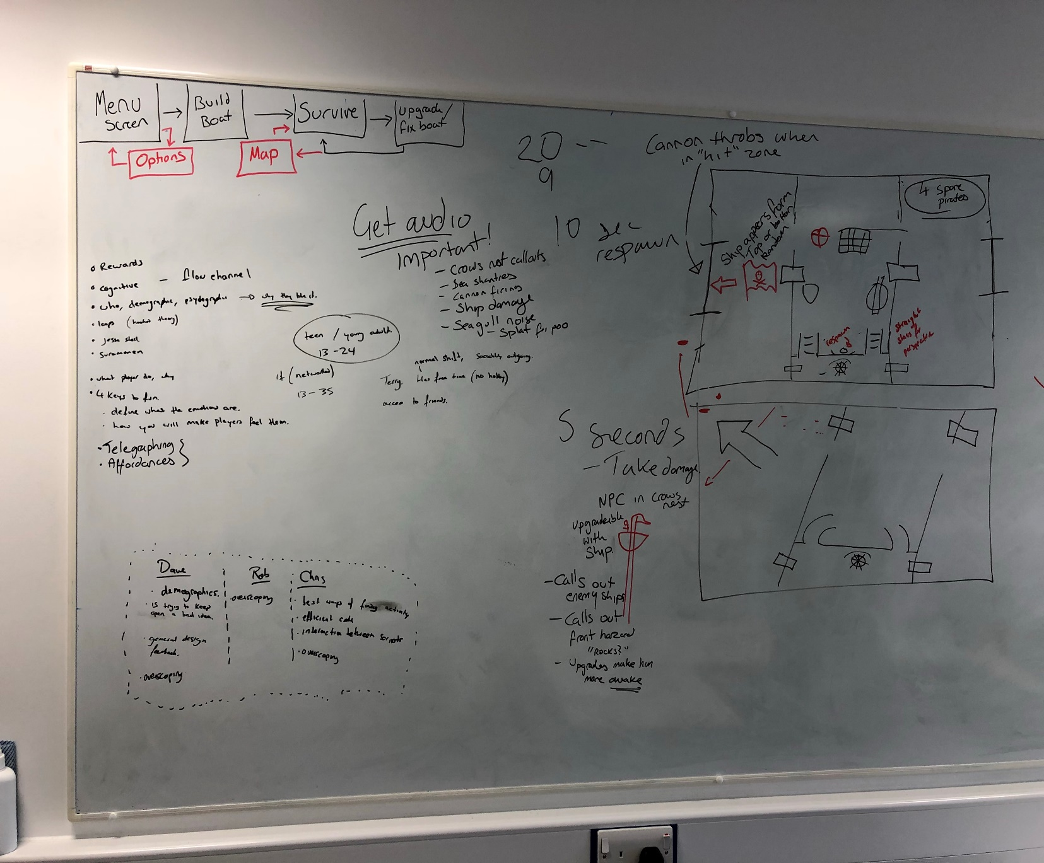

There will then be a hit point somewhere along the screen (shown by the two horizontal lines either side of the flag indicator) we are still deciding if these will be shown to the player or not, but when the enemy ship moves into this zone the correct cannon will start to throb, glow or play some kind of animation to alert the player that they need to fire, if they miss this window then the enemy ship will fire upon the player causing a hazard.

Because we are not showing the enemy ships on the screen this allows us to implement more than one enemy type without the need to produce multiple models and can just adjust the flag indicator accordingly. So far, the team has come up with two types of enemies, *pirates* and *British* with the idea of a boss battle being a stretch goal between a famous pirate such as *Blackbeard*. Pirates have been discussed to have a lower HP value being the *“easier”* enemy to deal with, while the British are more *“pirate hunters”* and have a higher HP value as they will have government backing.

***Telegraphing***

The team then started to discuss some telegraphing techniques that could be used to indicate actions, some of these techniques have been mentioned above;

* ***Speech Bubbles***
  + These will come from the NPC in the crow’s nest to alert the player to
    - Incoming enemy ships
    - Hazards that the ship needs to steer around
    - The overall damage / remaining HP of the ship
    - Time left until the level ends.
* ***Hit Marker for Enemy Cannon Fire***
  + The hit marker will show a location on the player’s ship where the enemy ship is about to fire their cannon, this will happen if the player has missed the window to fire upon the enemy. Once the cannon ball hits within the marker, if the player is within this marker at the time of impact then they will be killed and thrown overboard.
* ***Cannon Throbs when Enemy Ship in “Hit Zone”***
  + While the enemy ship is within the “Hit Zone” then a corresponding cannon will start to throb or show another animation to alert the player to the action required.
* ***Flag Moving Up or Down the Screen to Show Enemy Ship Location***
  + A flag will show on the side of the screen, this is related to the crow’s nest NPC level. This will show when an enemy is approaching the ship, coming alongside the ship and when the ship is leaving. The flag sprite will show what type of enemy is currently making a pass at the player ship depending on if they are a pirate or British.
* ***Water on the Deck***
  + As the player starts to take damage and leaves hazards uncontained water will start to appear on the deck, this is to give the player the impression that they are sinking, this will also start to slow the player down as they have to “wade” through the water.
* ***Flag to Show Player Ship HP***
  + We spoke about displaying a flag on the screen that would start to get more damaged as the player ship took damage to show the player their remaining HP without showing a number value however we also feel like this will start to clutter up the screen.
* ***Audio***
  + As a team we spoke about adding audio into the game
    - Crow’s Nest callouts
      * “Land Ho”
      * Some pirate slang to indicate the side enemies coming from “portside” etc
      * Some kind of land indication
      * Some form of damage indication
      * Challenge completion
      * Reward collection
    - Crew Audio
      * Sea Shanties
      * General pirate shouts (Morale dependant)
    - Ship Damage
    - Cannon Fire
    - General Sea sounds
    - Birds
    - Splat sound (for poo)
    - Hammering Wood sounds
    - Ship Creaking
    - Wind

***Rewards and Resources***

We spoke about players being rewarded with resources at the end of each level to go into their pool of resources. These resources are used to make temporary repairs during the level, at the end of each level players will have the choice to upgrade and repair their ship using their resources, however they will have to make sure they still have enough resources to survive the next level, however, the players will need to fully repair their ship before they are able to upgrade. The resources we have come up with so far are;

* Wood
  + Repair Hull damage.
  + Upgrade Hull.
* Metal
  + Repair cannons?
  + Upgrade cannons.
* Rum
  + Used as a morale level, to affect spawn times
  + Or used to affect player movement, keep it balanced between too drunk or hungover.
* Gold?
  + Used to purchase resources.
* Oranges?
  + Used to prevent scurvy.

Some other topics we spoke about were cannons having a recoil that would push them back requiring players to push them back into the correct firing position, players would have to load the cannon up with gunpower and then reload a cannon ball into the barrel before the cannon is able to fire again.

Resources could also have a chance to be lost when the player is fired upon, to increase the urgency of firing the cannon correctly. We also thought about putting in a negative feedback loop where if their player starts to do badly they will receive a few extra resources to ensure they do not enter a state where they can never progress.

Next team meeting scheduled for Tuesday 24rd October with Rob Kurta at 12:00PM

**Tasks for the current week:**

**Tom (12 Hours):**

* **As suggested by Dan spend time in the labs as a team in a game jam setting to increase team efficiency (8h)**

Dan Mayers agreed that we would benefit from spending time together in the labs to work together in a game jam / studio environment especially during the design phase.

* **Look into *“Guns of Icarus”* and see if there is any design choices that could be helpful to our game (45m)**

Extract design choices from a game called *“Guns of Icarus”* and pull out any design choices and balancing they do that could help with the progress of our game.

* **Meet with Rob Kurta (45m)**

Meet with Rob to discuss some of the design choices we have made in the game from the theory we have researched.

* **Meet with Dave Pimm (1h)**

Meet with Dave to discuss some of the design choices we have made in the game from the theory we have researched.

* **Meet with Chris Janes (30m)**

Detail types of immersion. Find examples of each, corresponding skills tested. Why they are effective.

* **Write a Design Document (1h)**

Write a brief design document outlining the direction the project will take to send to Dan Mayers

**Henry (12 Hours):**

* **As suggested by Dan spend time in the labs as a team in a game jam setting to increase team efficiency (8h)**

Dan Mayers agreed that we would benefit from spending time together in the labs to work together in a game jam / studio environment especially during the design phase.

* **Look into *“Pixel Piracy”* and see if there is any design choices that could be helpful to our game (45m)**

Extract design choices from a game called *“Pixel Piracy”* and pull out any design choices and balancing they do that could help with the progress of our game.

* **Meet with Rob Kurta (45m)**

Meet with Rob to discuss some of the design choices we have made in the game from the theory we have researched.

* **Meet with Dave Pimm (1h)**

Meet with Dave to discuss some of the design choices we have made in the game from the theory we have researched.

* **Meet with Chris Janes (30m)**

Detail types of immersion. Find examples of each, corresponding skills tested. Why they are effective.

* **Write a Risk Assessment Document (1h)**

Write a risk assessment showing the risks involved with the project and how the team aims to mitigate them and send to Dan Mayers

***Detailed tasks, task descriptions, user stories and time allocations are tracked on JIRA.***